Lab 11.5.4: Network Testing

Topology Diagram
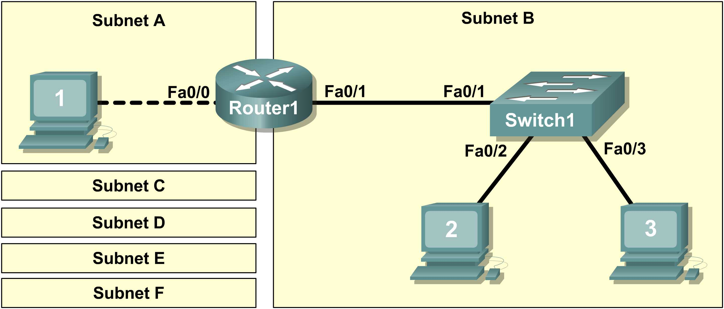

Learning Objectives
Upon completion of this lab, you will be able to:
- Design the logical lab topology.
- Configure the physical lab topology.
- Configure the logical LAN topology.
- Verify LAN connectivity.

Background

Hardware | Qty | Description
Cisco Router | 1 | Part of CCNA Lab bundle
Cisco Switch | 1 | Part of CCNA Lab bundle
*Computer (Host) | 3 | Lab computer
CAT-5 or better straight-through UTP cables | 3 | Connects Router1, Host1, and Host2 to switch1
CAT-5 crossover UTP cable | 1 | Connects Host 1 to Router1
Console (rollover) cable | 1 | Connects Host1 to Router1 console
Table 1. Equipment and Hardware for this Lab
Gather the necessary equipment and cables. To configure the lab, make sure the equipment listed in Table 1 is available.
The Appendix contains Cisco IOS configuration syntax for this lab.

Scenario
In this lab, you will create a small network that requires connecting network devices and configuring host computers for basic network connectivity. SubnetA and SubnetB are subnets that are currently needed. SubnetC, SubnetD, SubnetE, and SubnetF are anticipated subnets, not yet connected to the network.
Task 1: Design the Logical Lab Topology.
Given an IP address and mask of 172.20.0.0 / 24 (address / mask), design an IP addressing scheme that satisfies the following requirements:

Subnet | Number of Hosts
SubnetA | As shown in topology diagram
SubnetB | Between 80 – 100
SubnetC | Between 40 – 52
SubnetD | Between 20 – 29
SubnetE | 12
SubnetF | 5

Note: Always start with the subnet with the largest number of hosts and work your way down. Therefore, you should start with SubnetB and finish with SubnetA.
Step 1: Design SubnetB address block.
Begin the logical network design by satisfying the requirement of SubnetB, which requires the largest block of IP addresses. Using binary numbers to create your subnet chart, pick the first address block that will support SubnetB.
- Fill in the following table with IP address information for SubnetB:

Network Address | Mask | First Host Address | Last Host Address | Broadcast

- What is the bit mask in binary? ____________________________________________________
Step 2: Design SubnetC address block.
Satisfy the requirement of SubnetC, the next largest IP address block. Using binary numbers to create your subnet chart, pick the next available address block that will support SubnetC.
- Fill in the following table with IP address information for SubnetC:

Network Address | Mask | First Host Address | Last Host Address | Broadcast

- What is the bit mask in binary? ____________________________________________________
Step 3: Design SubnetD address block.
Satisfy the requirement of SubnetD, the next largest IP address block. Using binary numbers to create your subnet chart, pick the next available address block that will support SubnetD.
- Fill in the following table with IP address information for SubnetD:

Network Address | Mask | First Host Address | Last Host Address | Broadcast

- What is the bit mask in binary? ____________________________________________________
Step 4: Design SubnetE address block.
Satisfy the requirement of SubnetE, the next largest IP address block. Using binary numbers to create your subnet chart, pick the next available address block that will support SubnetE.
- Fill in the following table with IP address information for SubnetE:

Network Address | Mask | First Host Address | Last Host Address | Broadcast

- What is the bit mask in binary? ____________________________________________________
Step 5: Design SubnetF address block.
Satisfy the requirement of SubnetF, the next largest IP address block. Using binary numbers to create your subnet chart, pick the next available address block that will support SubnetF.
- Fill in the following table with IP address information for SubnetF:

Network Address | Mask | First Host Address | Last Host Address | Broadcast

- What is the bit mask in binary? ____________________________________________________
Step 6: Design SubnetA address block.
Satisfy the requirement of SubnetA, the smallest IP address block. Using binary numbers to create your subnet chart, pick the next available address block that will support SubnetA.
- Fill in the following table with IP address information for SubnetA:

Network Address | Mask | First Host Address | Last Host Address | Broadcast

- What is the bit mask in binary? ____________________________________________________
Task 2: Configure the Physical Lab Topology.
Step 1: Physically connect lab devices.
- Cable the network devices as shown in Figure 1. Pay special attention to the crossover cable required between Host1 and Router1.
Figure 1. Cabling the Network
- If not already enabled, turn power on to all devices.
Step 2: Visually inspect network connections.
After cabling the network devices, take a moment to verify the connections. Attention to detail now will minimize the time required to troubleshoot Layer 1 connectivity issues later.
Task 3: Configure the Logical Topology.
Step 1: Document logical network settings.
On SubnetA, Host1 will use the first IP address in the subnet. Router1, interface Fa0/0, will use the last host address. On SubnetB, host computers will use the first and second IP addresses in the subnet, respectively. Router1, interface Fa0/1, will use the last network host address.
To properly route Layer 2 frames between LAN devices, Switch1 does not require Layer 3 configuration. The IP address assigned to Switch 1, interface VLAN 1, is used to establish Layer 3 connectivity between external devices and the switch. Without an IP address, upper-layer protocols such as TELNET and HTTP will not work. The default gateway address permits the switch to respond to protocol requests from devices on distant networks. For example, the IP gateway address extends Layer 3 connectivity beyond Subnet B. Switch1 will use the next-to-last host address.
Write down the IP address information for each device:
Device | Subnet | IP Address | Mask | Gateway
Host1
Router1-Fa0/0
Host2
Host3
Switch1
Router1-Fa0/1
Step 2: Configure host computers.
- On each computer, in turn, click Start > Control Panel > Network Connections. Right-click the LAN icon, and choose Properties. On the General tab, select Internet Protocol (TCP/IP), and then click the, Properties button.
- Verify that the Host1 Layer 3 IP address is on a different subnet than Host2 and Host3. Configure each host computer using the IP address information recorded in Step 1.
- Verify proper configuration of each host computer with the ipconfig command and fill in the following table:

Device | IP Address | Mask | Default Gateway
Host1
Host2
Host3
Step 3: Configure Router1.
- From the Windows taskbar, start the HyperTerminal program by clicking Start > Programs > Accessories > Communications > HyperTerminal. Configure HyperTerminal for access to Router1. Configuration for Router1 includes the following tasks:

Tasks
(Refer to the Appendix for help with commands)
Specify Router name: Router1
Specify an encrypted privileged EXEC password: cisco
Specify a console access password: class
Specify a telnet access password: class
Configure the MOTD banner
Configure Router1 interface Fa0/0:
- Set the description
- Set the Layer 3 address
- Issue no shutdown
Configure Router1 interface Fa0/1:
- Set the description
- Set the Layer 3 address
- Issue no shutdown

- Save the configuration in NVRAM.
- Display the contents of RAM:
- Write the configuration specifications below:
Hostname: ________________________
Enable secret password: ________________________
Console access password: ________________________
Telnet access password: ________________________
MOTD banner: ________________________
- Display configuration information for interface Fa0/0: show interface Fa0/0
FastEthernet 0/0 status (up / down): ________________________
Line protocol: ________________________
MAC Address: ________________________

- Display configuration information for interface Fa0/1: show interface Fa0/1
FastEthernet 0/0 status (up / down): ________________________
Line protocol: ________________________
MAC Address: ________________________

- Display brief IP address information about each interface: show ip interface brief

Interface IP-Address OK? Method Status Protocol

FastEthernet0/0

FastEthernet0/1
- Take corrective action with any problems, and retest.
Task 4: Clean Up.
Unless directed otherwise by the instructor, restore host computer network connectivity, and then turn off power to the host computers.
Before turning off power to the router and switch, remove the NVRAM configuration file from each device with the privileged exec command erase startup-config.
Carefully remove cables and return them neatly to their storage. Reconnect cables that were disconnected for this lab.
Remove anything that was brought into the lab, and leave the room ready for the next class.
Appendix—List of Cisco IOS commands used in this lab
Purpose | Command
Enter the global configuration mode. | configure terminal  Example:  Router>enable  Router#configure terminal  Router(config)#
Specify the name for the Cisco device. | hostname name  Example:  Router(config)#hostname Router1  Router(config)#
Specify an encrypted password to prevent unauthorized access to the privileged EXEC mode. | Enable secret password  Example:  Router(config)#enable secret cisco  Router(config)#
Specify a password to prevent unauthorized access to the console. | password password  login  Example:  Router(config)#line con 0  Router(config-line)#password class  Router(config-line)#login  Router(config)#
Specify a password to prevent unauthorized Telnet access.  Router vty lines: 0 4  Switch vty lines: 0 15 | password password  login  Example:  Router(config)#line vty 0 4  Router(config-line)#password class  Router(config-line)#login  Router(config-line)#
Configure the MOTD banner. | Banner motd %  Example:  Router(config)#banner motd %  Router(config)#
Configure a Router interface.  Router interface is OFF by default | Example:  Router(config)#interface Fa0/0 Router(config-if)#description description  Router(config-if)#ip address address mask  Router(config-if)#no shutdown  Router(config-if)#
Save the configuration to NVRAM. | copy running-config startup-config  Example:  Router#copy running-config startup-config

